**SUPPLEMENTARY INFORMATION**

**Functional Reconfiguration of Task-Active Frontoparietal Control Network Facilitates Abstract Reasoning**

Thomas M. Morin1,3, Kylie N. Moore1,3, Kylie Isenburg1,3, Weida Ma3, & Chantal E. Stern1,2,3

Boston University

1Graduate Program for Neuroscience, Boston University

2Department of Psychological and Brain Sciences, Boston University

3Cognitive Neuroimaging Center, Boston University

Author Note

Correspondence regarding this article should be addressed to Chantal Stern, Kilachand Center for Integrated Life Sciences and Engineering, Boston University, Boston, Massachusetts, 02215. Email: [chantal@bu.edu](mailto:chantal@bu.edu) Phone: 617-353-1396

Running Title: SUPPLEMENTARY INFORMATION

**Supplementary Methods**

## *Preprocessing in fMRIprep*

The following is a boilerplate statement output by the fMRIprep preprocessing pipeline that we used for our anatomical, task, and resting state MRI scans:

Anatomical T1-weighted (T1w) images were corrected for intensity non-uniformity (INU) with `N4BiasFieldCorrection` (Tustison et al., 2010), distributed with ANTs 2.3.1 (Avants et al., 2008), and used as T1w-reference throughout the workflow. The T1w-reference was then skull-stripped with a Nipype implementation of the `antsBrainExtraction.sh` workflow (from ANTs), using OASIS30ANTs as target template. Brain tissue segmentation of cerebrospinal fluid (CSF), white-matter (WM), and gray-matter (GM) was performed on the brain-extracted T1w using `fast` [FSL 6.0.1] (Zhang et al., 2001). Brain surfaces were reconstructed using `recon-all` [FreeSurfer 6.0.0] (Dale et al., 1999), and the brain mask estimated previously was refined with a custom variation of the method to reconcile ANTs-derived and FreeSurfer-derived segmentations of the cortical gray-matter of Mindboggle (Klein et al., 2017). Volume-based spatial normalization to one standard space (MNI152NLin2009cAsym) was performed through nonlinear registration with `antsRegistration` (ANTs 2.3.1), using brain-extracted versions of both T1w reference and the T1w template. The following template was selected for spatial normalization: ICBM 152 Nonlinear Asymmetrical template version 2009c (Fonov et al., 2009).

The following preprocessing steps were performed on the resting-state and task BOLD scans for each subject. First, a reference volume and its skull-stripped version were generated using a custom methodology of fMRIPrep. A deformation field to correct for susceptibility distortions was estimated based on two echo-planar imaging (EPI) references with opposing phase-encoding directions, using `3dQwarp` (AFNI 2019.01.00) (Cox & Hyde, 1997). Based on the estimated susceptibility distortion, an unwarped BOLD reference was calculated for a more accurate co-registration with the anatomical reference. The BOLD reference was then co-registered to the T1w reference using `bbregister` (FreeSurfer) which implements boundary-based registration (Greve & Fischl, 2009). Co-registration was configured with nine degrees of freedom to account for distortions remaining in the BOLD reference. Head-motion parameters with respect to the BOLD reference (transformation matrices, and six corresponding rotation and translation parameters) are estimated before any spatiotemporal filtering using `mcflirt` [FSL 6.0.1] (Jenkinson et al., 2002). BOLD runs were slice-time corrected using `3dTshift` from AFNI 2019.01.00 (Cox & Hyde, 1997). The BOLD time-series, were resampled to surfaces on the following spaces: fsaverage. The BOLD time-series (including slice-timing correction when applied) were resampled onto their original, native space by applying a single, composite transform to correct for head-motion and susceptibility distortions. These resampled BOLD time-series will be referred to as preprocessed BOLD in original space, or just preprocessed BOLD. The BOLD time-series were resampled into standard space, generating a preprocessed BOLD run in 'MNI152NLin2009cAsym' space. First, a reference volume and its skull-stripped version were generated using a custom methodology of fMRIPrep. Several confounding time-series were calculated based on the preprocessed BOLD: framewise displacement (FD), DVARS and three region-wise global signals. FD and DVARS are calculated for each functional run, both using their implementations in Nipype [following the definitions by (Power et al., 2014)]. The three global signals are extracted within the CSF, the WM, and the whole-brain masks. The head-motion estimates calculated in the correction step were placed within the corresponding confounds file. The confound time series derived from head motion estimates and global signals were expanded with the inclusion of temporal derivatives and quadratic terms for each (Satterthwaite et al., 2013). Frames that exceeded a threshold of 0.5 mm FD or 1.5 standardised DVARS were annotated as motion outliers.

All resamplings can be performed with a single interpolation step by composing all the pertinent transformations (i.e. head-motion transform matrices, susceptibility distortion correction when available, and co-registrations to anatomical and output spaces). Gridded (volumetric) resamplings were performed using `antsApplyTransforms` (ANTs), configured with Lanczos interpolation to minimize the smoothing effects of other kernels (Lanczos, 1964). Non-gridded (surface) resamplings were performed using `mri_vol2surf` (FreeSurfer). Many internal operations of fMRIPrep use Nilearn 0.5.2 (Abraham et al., 2014), mostly within the functional processing workflow. For more details of the pipeline, see the section corresponding to workflows in fMRIPrep's documentation (https://fmriprep.readthedocs.io/en/latest/workflows.html).

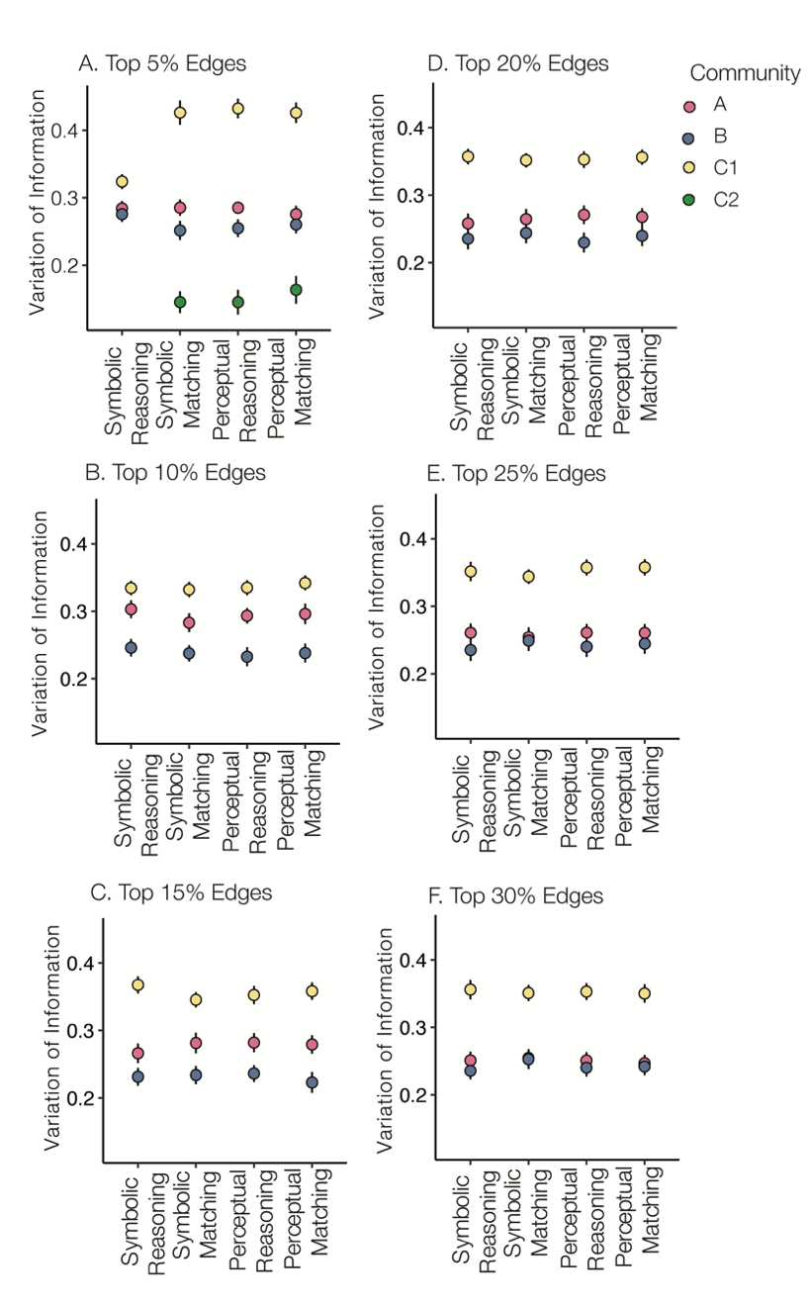

**Figure S1 Variation of Information Across Edge Thresholds**

To quantify the difference in community assignment between each task condition and the resting state we plotted the variation of information (VIn) for each of the task communities. Points represent mean VIn across subjects. Results are presented for subjects’ functional connectivity networks thresholded at six levels (top 5, 10, 15, 20, 25, and 30% of edges in the network) (A-F). Error bars represent standard error. Nodes in community C showed the largest change in community assignment for all four conditions, compared to rest across all six thresholds. Red = community A, Blue = community B, Yellow = community C. For the 5% thresholded network (panel A), Community C remained intact during symbolic reasoning, but split into two subnetworks C1 (Yellow) and C2 (Green) for the other three task conditions.

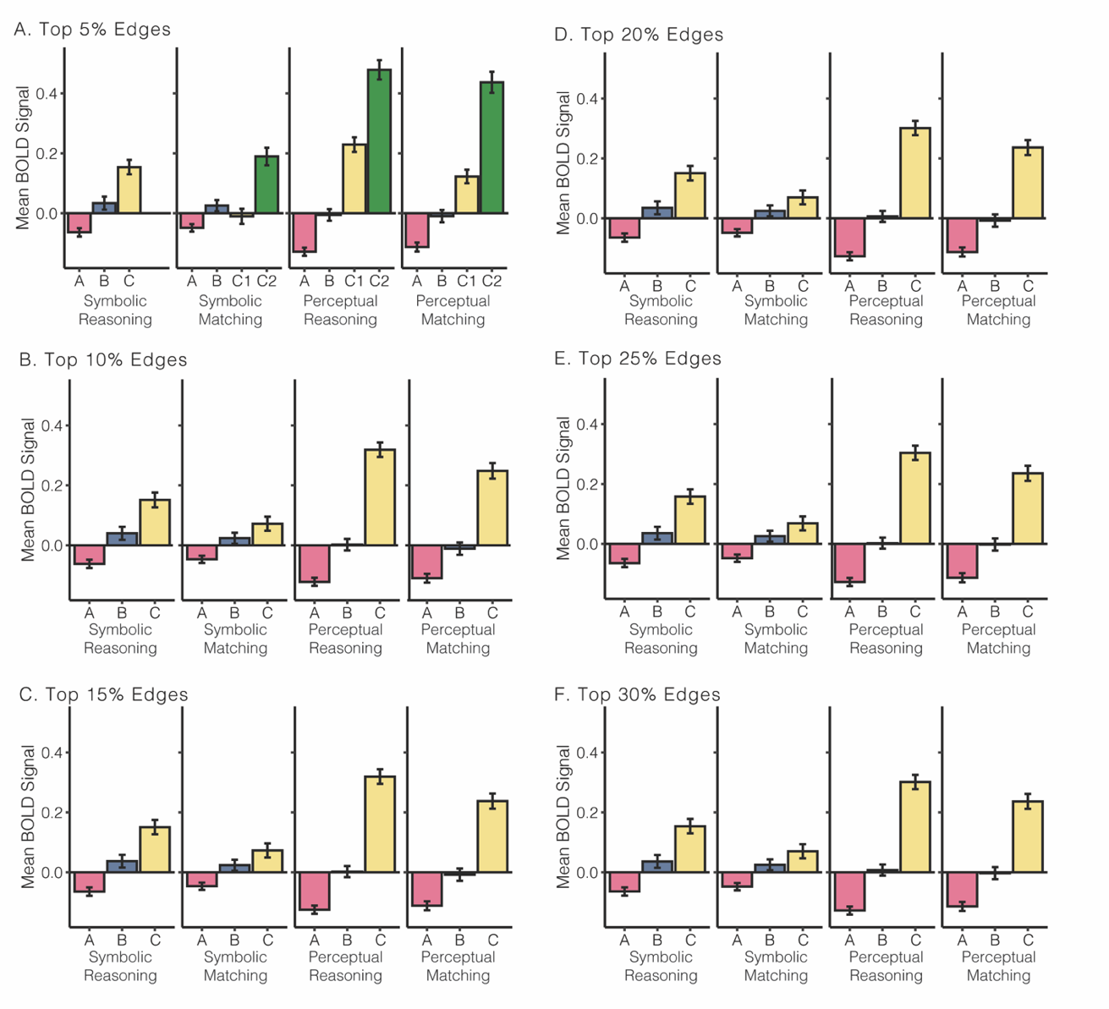

**Figure S2 Community Activation Across Edge Thresholds**

The mean BOLD signal within each task community is plotted for each of the task conditions. Bar height represents the mean BOLD signal across subjects for each community. Results are presented for subjects’ functional connectivity networks thresholded at six levels (top 5, 10, 15, 20, 25, and 30% of edges in the network) (A-F). Error bars represent standard error. Red = community A, Blue = community B, Yellow = community C. For the 5% thresholded network (panel A), Community C remained intact during symbolic reasoning, but split into two subnetworks C1 (Yellow) and C2 (Green) for the other three task conditions.



**Figure S3 Effect of Shorter TR on Resting State Network Community Assignments**

We observed that the brain’s functional network structure was reconfigured from a fragmented set of communities at rest to a more cohesive community structure during the task (see Figure 4). Here we repeated the network reconfiguration analysis to determine whether the shorter TR of the resting state fMRI scans may have influenced the community structure (Resting State: TR = 1.0s, Slice Acceleration = 6; Task: TR = 2.0s, Slice Acceleration = 3). **A.** The resting state communities from the original analysis are shown. **B.** The decreased signal-to-noise ratio (SNR) that typically accompanies an increase in temporal resolution could result in reduced coherence among networks and a more fractured community structure. We checked the effect of decreased SNR on community structure at rest, by analyzing each of the three resting state runs separately. **C.** The increased temporal resolution of the rest data could enable finer distinctions among communities. To account for this, we downsampled the resting state data by averaging adjacent pairs of TRs to match the effective temporal resolution of the task data. **D & E.** To quantify differences in community assignment between the original and follow-up analyses, we calculated the variation of information (VIn) for nodes within each of the seven Yeo communities. VIn quantifies how similar two network partitions are, with a lower value indicating more similar community assignments and a higher value indicating a larger shift in community assignments. Across all analyses, default, visual, and somatomotor nodes showed similar community assignments (lower VIn). Conversely, ventral attention, limbic, cognitive control, and dorsal attention nodes showed variation in community assignments (higher VIn). The consistent regional variability of VIn suggests that the fractionated community structure of frontoparietal nodes is due, at least in part, to weak and unstable functional connectivity in those regions. If the short TR used in the resting state scans was affecting community structure, we would expect to see systemic changes in community structure throughout the entire brain.

**Works Cited**

Abraham, A., Pedregosa, F., Eickenberg, M., Gervais, P., Mueller, A., Kossaifi, J., Gramfort, A., Thirion, B., & Varoquaux, G. (2014). Machine learning for neuroimaging with scikit-learn. *Frontiers in Neuroinformatics*, *8*. https://doi.org/10.3389/fninf.2014.00014

Avants, B. B., Epstein, C. L., Grossman, M., & Gee, J. C. (2008). Symmetric diffeomorphic image registration with cross-correlation: Evaluating automated labeling of elderly and neurodegenerative brain. *Medical Image Analysis*, *12*(1), 26–41. https://doi.org/10.1016/j.media.2007.06.004

Cox, R. W., & Hyde, J. S. (1997). Software tools for analysis and visualization of fMRI data. *NMR in Biomedicine*, *10*(4–5), 171–178. https://doi.org/10.1002/(SICI)1099-1492(199706/08)10:4/5<171::AID-NBM453>3.0.CO;2-L

Dale, A. M., Fischl, B., & Sereno, M. I. (1999). Cortical Surface-Based Analysis: I. Segmentation and Surface Reconstruction. *NeuroImage*, *9*(2), 179–194. https://doi.org/10.1006/nimg.1998.0395

Fonov, V. S., Evans, A. C., McKinstry, R. C., Almli, C. R., & Collins, D. L. (2009). Unbiased nonlinear average age-appropriate brain templates from birth to adulthood. *NeuroImage*, *47, Supple*, S102. https://doi.org/10.1016/S1053-8119(09)70884-5

Greve, D. N., & Fischl, B. (2009). Accurate and robust brain image alignment using boundary-based registration. *NeuroImage*, *48*(1), 63–72. https://doi.org/10.1016/j.neuroimage.2009.06.060

Jenkinson, M., Bannister, P., Brady, M., & Smith, S. (2002). Improved Optimization for the Robust and Accurate Linear Registration and Motion Correction of Brain Images. *NeuroImage*, *17*(2), 825–841. https://doi.org/10.1006/nimg.2002.1132

Klein, A., Ghosh, S. S., Bao, F. S., Giard, J., Häme, Y., Stavsky, E., Lee, N., Rossa, B., Reuter, M., Neto, E. C., & Keshavan, A. (2017). Mindboggling morphometry of human brains. *PLOS Computational Biology*, *13*(2), e1005350. https://doi.org/10.1371/journal.pcbi.1005350

Lanczos, C. (1964). Evaluation of Noisy Data. *Journal of the Society for Industrial and Applied Mathematics Series B Numerical Analysis*, *1*(1), 76–85. https://doi.org/10.1137/0701007

Power, J. D., Mitra, A., Laumann, T. O., Snyder, A. Z., Schlaggar, B. L., & Petersen, S. E. (2014). Methods to detect, characterize, and remove motion artifact in resting state fMRI. *NeuroImage*, *84*(Supplement C), 320–341. https://doi.org/10.1016/j.neuroimage.2013.08.048

Satterthwaite, T. D., Elliott, M. A., Gerraty, R. T., Ruparel, K., Loughead, J., Calkins, M. E., Eickhoff, S. B., Hakonarson, H., Gur, R. C., Gur, R. E., & Wolf, D. H. (2013). An improved framework for confound regression and filtering for control of motion artifact in the preprocessing of resting-state functional connectivity data. *NeuroImage*, *64*(1), 240–256. https://doi.org/10.1016/j.neuroimage.2012.08.052

Tustison, N. J., Avants, B. B., Cook, P. A., Zheng, Y., Egan, A., Yushkevich, P. A., & Gee, J. C. (2010). N4ITK: Improved N3 Bias Correction. *IEEE Transactions on Medical Imaging*, *29*(6), 1310–1320. https://doi.org/10.1109/TMI.2010.2046908

Zhang, Y., Brady, M., & Smith, S. (2001). Segmentation of brain {MR} images through a hidden Markov random field model and the expectation-maximization algorithm. *IEEE Transactions on Medical Imaging*, *20*(1), 45–57. https://doi.org/10.1109/42.906424